 | STARTUP | PROV | SETTORE
1 | 3D FLIX | RE | DIGITALE
2 | ARCHIBUDGET | RE | EDILIZIA
3 | BONSAY | BO | HR
4 | COYZY | PI | PREVTECH
5 | DEEPMAMMO | PI | A.I.
6 | ENERGAID | TV | ENERGIA E AMBIENTE
7 | E-STEPS | BO | BIOMEDICALE
8 | EYECAN | BO | INDUSTRIAL ICT
9 | FRIECO | VC | CLEANTECH, CIRCULAR ECONOMY
10 | FUEL | AN | EDTECH
11 | GETLOCKY | RE | LOGISTICA
12 | HOORO | BO | RETAILTECH
13 | MAT | MO | AUTOMOTIVE
14 | MECHANIKA PARTS | MO | MECCANICA 4.0
15 | MONITOR THE PLANET | RA | INGEGNERIA GEOMATICA
16 | MORPHOGRAM | TE | E-HEALTH
17 | NEURALITY | RN | AUTOMAZIONE DI PROCESSI
18 | NONSTUDIO | FC | E-LEARNING
19 | PICK-ROLL | RM | INFORMATICA
20 | PIQAPART | RA | INDUSTRIA 4.0
21 | PLATO ELEARNING | PR | SOFTWARE, IT
22 | PONY PONY | FC | LOGISTICA
23 | RE LEARN | TO | A.I. E SOSTENIBILITA'
24 | RECOVER INGREDIENTS | BO | COSMETICA
25 | REVOTREE | MI | AGTECH
26 | SELL IN TO CHINA | MO | E-COMMERCE & DIGITAL EXPORT
27 | SMARTWEAR | RE | TECNOLOGIA SALUTE E BENESSERE
28 | SOMMELIER WINE BOX | PD | WINE
29 | SOPLAYA | UD | FOODTECH
30 | SQUISEAT | BO | FOOD
31 | STIMALO | TV | PROPTECH
32 | TAYLORA | VI | INFORMATICA
33 | THE BEST IDEA | PD | SERVIZI DIGITALI
34 | TOMAPAINT | PR | MATERIALI PER IL PACKAGING
35 | TRAXIT | BO | MECCATRONICA
36 | VIDRA | BI | FINTECH
37 | WIGUEST | MI | TURISMO E RICETTIVITA'
38 | ZEN-ON | BO | INDUSTRY 4.0/ A.I.
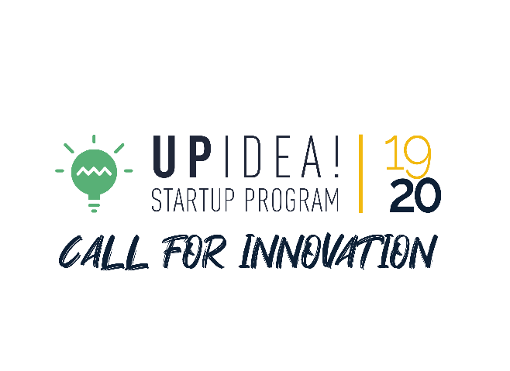
BOOTCAMP
11/12 dicembre 2019

